Chapter 8, Problem 26.

The step response of an RLC circuit is given by

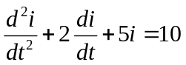

Given that i(0) = 2 and di(0)/dt = 4, solve for i(t).

